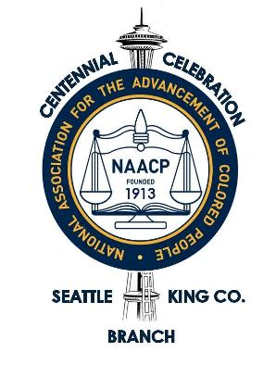
NAACP Seattle King County
Celebrating 100 Years 1913 - 2013

Committee Chair: Cynthia Hobbs
Honorary Chair: Attorney Lembhard Howell
Honorary Co-Chair Judge Donald Haley (ret)
Honorary Co-Chair Charles V. Johnson (ret)
Honorary Co-Chair President Emeritus Lacy Steele
Media Advisory
Sept. 30, 2013
Contact:
Cynthia Hobbs (206) 324-6600 or cynhobbs@aol.com

Seattle King County NAACP Celebrates 100 Years,
Honors Longtime Members and Civil Rights Leaders

SEATTLE – The Seattle King County NAACP is celebrating a century of advocating for racial justice and equality in the Pacific Northwest. On Nov. 2, the contributions of its past presidents and longest serving committee members will be recognized:

- Hon. Charles V. Johnson – Retired King County Superior Court Judge
- Hon. Donald Haley – Retired King County Superior Court Judge
- President Emeritus Lacy Steele – First African American manager at Boeing,
Aerospace Quality Assurance, Retired

Each honoree has given more than 50 years of continuous service to the NAACP.

Other special guests will include keynote speaker Benjamin Todd Jealous, president and CEO of the national NAACP; and Bishop John Hurst Adams, civil rights leader and pastor of First African Methodist Episcopal Church in Seattle from 1962 until 1968.

During the past 100 years, the Seattle King County NAACP has successfully advocated for interracial marriage, the right for African Americans to buy a house in any neighborhood, to be served at restaurants, for equal employment opportunity and for excellence in education.

“Some of the fights we had back then would surprise you,” said Donald Haley, who joined the NAACP after graduating from the University of Washington School of Law in 1958. “It’s not over with.”

Those fights included pushing for jobs for African American women in grocery stores and downtown department stores, and for open housing in neighborhoods. The NAACP helped connect homebuyers with willing sellers and lenders.
Continued …

NAACP, page 2

“A lot of organizations come and go, but the NAACP is still around today. It has a good reputation, and it still has an important role today,” said Haley.

Judge Charles Johnson recalls the Freedom Patrols of the 1960s when NAACP members would pair up and walk a short distance behind police officers as witnesses to potential racial incidents.

Lacy Steele was in the front row for many of the fights, serving as the president of Seattle King County NAACP for 26 years and representing the local branch at national NAACP meetings.

Steele said employment – especially for African American youth – education, criminal justice, police oversight, and voter registration continue to be the most important issues the NAACP works on.

“You have to vote, you have to be part of solving the problem,” said Steele. “We have a black president, but how many African American senators are there? There is still a lot of work to do.”

_________________

The Seattle King County NAACP is celebrating a century of service to the Pacific Northwest with a dinner, dance, and ceremony recognizing NAACP leadership. The celebration “Bold Dreams, Big Victories” will be held Saturday, Nov. 2 at the Double Tree Hilton – Airport.

Tickets are $100 and are available by calling the NAACP office at (206) 324-6600 or at http://www.brownpapertickets.com/event/397395 More information is available at www.seattlekingcountynaacp.org

The Seattle King County Branch of the NAACP, founded in 1913, is the oldest branch west of the Mississippi River. The Seattle branch has always been in the forefront of the civil rights movement.

# # #

